ARTICLE REVIEW

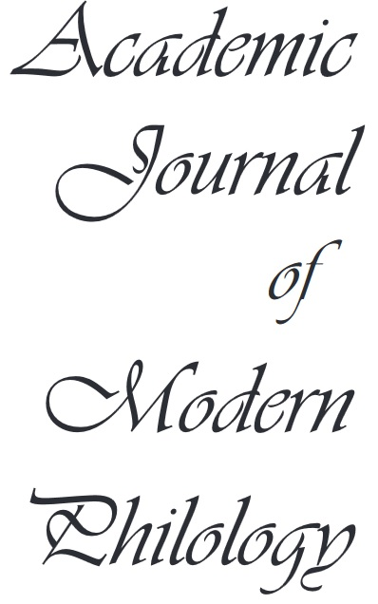


Thank you for agreeing to review an article for AJMP. Your review will be anonymous. If you wish, you may submit comments in the “final decision” section or in the article manuscript itself (review comments). All refereeing reports are treated as confidential material.
I. GENERAL INFORMATION
Article Title: ………………………………………………………………………………….
Article Author ………………………………………………………………………………….
Author’s Affiliation ………………………………………………………………………………….
Assigned Reviewer: ………………………………………………………………………………….
Date: ………………………………………………………………………………….

- SCIENTIFIC CRITERIA
REVIEW CRITERIA | QUESTIONS | SCALE
- ORIGINALITY  Positive responses to these questions represent high originality ratings. Negative responses for these questions represent low originality ratings. | - Are the problems discussed in the article new?  - Does the article point out differences from related research?  - Does the article introduce an idea that appears promising or might stimulate others to develop promising alternatives? | □ poor  □ needs improvements  □ average  □ good  □ excellent
- SIGNIFICANCE  Positive responses to these questions represent high significance ratings. Negative responses to these questions represent low significance ratings. | - Does the article make a considerable contribution to a certain area of research?  - Does the article stimulate discussion of important issues or alternative points of view? | □ poor  □ needs improvements  □ average  □ good  □ excellent
- RELEVANCE  Positive responses to these questions represent high relevance ratings. Negative responses to these questions represent low relevance ratings. | - Does the article present relevant information for its area of research? | □ poor  □ needs improvements  □ average  □ good  □ excellent
- PRESENTATION  Positive responses to these questions represent high presentation ratings. Negative responses for these questions represent low presentation ratings. | - Does the article have a logical structure?  - Is the article clearly written?  - Is the article correctly written (from the grammar point of view)?  - Does the article present in an appropriate way the terminology for its area of interest? | □ poor  □ needs improvements  □ average  □ good  □ excellent
- CONTENT  Positive responses to these questions represent high content ratings. Negative responses to these questions represent low content ratings. |  | □ poor  □ needs improvements  □ average  □ good  □ excellent
- Title | - Does the title clearly express the content of the article? | □ poor  □ needs improvements  □ average  □ good  □ excellent
- Abstract | - Is the abstract sufficiently informative?  - Does the abstract describe the research and the results?  - Does the abstract provide a good perspective on the final message of the article? | □ poor  □ needs improvements  □ average  □ good  □ excellent
- Introduction | - Does the introduction correctly highlight the current concerns in the area?  - Does the introduction specify the research objectives? | □ poor  □ needs improvements  □ average  □ good  □ excellent
- Methodology | - Are the methods used clearly explained?  - Are the methods used validated / recognized?  - Are the data used reliable? | □ poor  □ needs improvements  □ average  □ good  □ excellent
- Results | - Are the results clearly presented?  - Are all relevant connections with others’ work/research declared?  - Is literature used in support of research sufficiently comprehensive and current?  - Do the results sufficiently avoid assumptions and speculations? | □ poor  □ needs improvements  □ average  □ good  □ excellent
- Conclusions | - Are the conclusions correctly / logically explained?  - Do the conclusions sufficiently avoid misinterpretation?  - Do the conclusions sufficiently avoid too general or biased information? | □ poor  □ needs improvements  □ average  □ good  □ excellent
- References | - Do the references reflect the latest work/research in the considered area??  - Are the references correctly indicated in the article?  - Are the references properly indexed and recorded in the bibliography? | □ poor  □ needs improvements  □ average  □ good  □ excellent
- Graphs and figures | - Do the graphs and figures properly illustrate the discussed subject?  - Are the graphs and figures correctly named and numbered?  - Are the data presented in graphs and figures correctly valued and interpreted in the article? | □ poor  □ needs improvements  □ average  □ good  □ excellent
- PLAGIARISM | - If an article (or parts from an article) is suspected to be a substantial copy of an earlier work, the article is rejected. | □ Accepted  □ Rejected

III. FINAL DECISION
Please indicate which of the following actions you recommend.
- Publish, no significant alterations suggested.
- Publish, but suggest changes to the article as specified in this review.
- Reject, but encourage the author to try a major revision and a second peer review.
- Reject, do not encourage a rewrite.

- Reviewers’ recommendations on improvements and revision (if any):
……………………………………………………………………………………………………………………………………………………………………………………………………………………………………………………………………………………………………………………………………………………….……………………………………………………………………………………………………………………………………………………………………………………………………………………………………………………………………………………………………………………………………………………….………………………………………………………………………………………………………………………………………………………………………………………………………………………………………………………………………………………………………………………………………………………………………………………………………………………………………………………………………………………………………………………………………………………………………………………………………………………………………………………………………………………………………………………………………………………………………………………………………………………………………………………………………………………………………………………………………………………………………………………………………………………………………………………………………………………………………………………………………………………………………………………………………………………………………………………………………………………………………………………………………………………………………………………………………………………………………………………………………………………………………………………………………………………………………………………………………………………………………………………………………………………………………………………………………………………………………………………

